Servlet Work Flow and Life Cycle
Table of Contents
Servlet Workflow 2
Example Application 2
Starting the Server 2
Task 1 of Web Server 2
Task 2 of Web Server 3
Request is made 3
Scenario 1: A static page is requested 3
Scenario 2: A dynamic page is requested 3
HTTP Protocol 3
Request reaches the Web Server 4
Web Server checks the request 4
Web Server locates the resources 4
Servlet Life Cycle 5
1. Servlet Loading 5
2. Servlet Instantiation 5
3. Servlet Initialization 5
4. Thread Creation and Data Processing 6
Brief Life cycle 7

Servlet Workflow
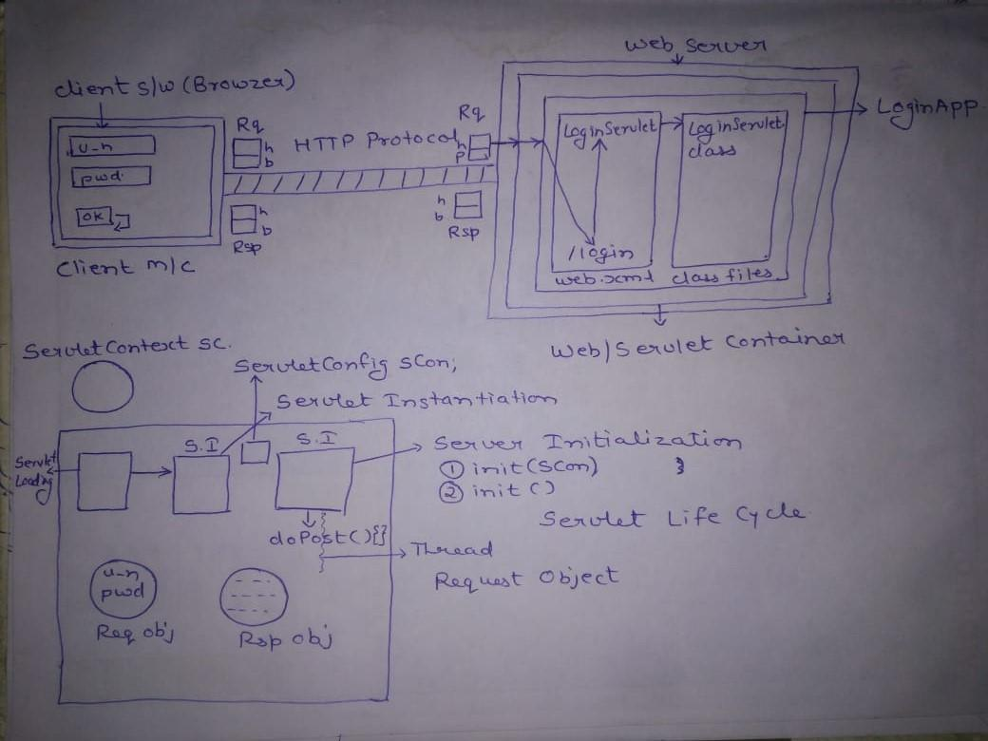

Example Application
To understand Servlet Workflow, consider an example application. This example includes:
- A Web Application named as LoginApplication
- This Web Application contains an html page login.html, a servlet LoginServlet and a web.xml file
- This login form will have 2 fields: user_name and password.
- The form tag contains attributes: method=”post”, action=”login”
- The servlet LoginServlet has URL pattern “/login”

Starting the Server

Task 1 of Web Server
When we start the web server the job of the web container is:
- To recognize all the web applications
- Deploy each web application on the server, and
- Prepare a separate object for each web application.
- This object is known as ServletContext Object.

For example, as we start Tomcat Web Server, the web container
- Recognizes the Login application
- Deploy it to the server and
- Prepare an object for Login Application called ServletContext Object.

Task 2 of Web Server
The web container also
- Recognizes the web.xml file present inside the WEB-INF folder.
- Loads the web.xml file
- Parses the file and
- Reads the content of the file.
- If any application level data is available, the container will store this data inside the ServletContext object.

Request is made

Scenario 1: A static page is requested
The Web Server is responsible to deliver static content to the client. So, as a request is made from the client browser, the requested static page is delivered through the web server to the client browser.

Scenario 2: A dynamic page is requested
Prerequisite
1: A page is displayed in the browser.
2: The page contains a login form with 2 input fields: username and password.
Step 1: The data is entered in the form fields and button is clicked.

HTTP Protocol
- The request will come to protocol (here HTTP).
- Protocol will establish a virtual socket connection between client and server on the basis of server IP address and port number.
- After preparing the socket connection, the protocol will prepare a request format.
- The request format contains 2 parts:
  - Header part
  - Body part.

Header Part
The header will manage request headers. Request headers contain details about the client browser such as:
- The Locale managed by the client browser
- The Zipping formats supported by the client browser
- The Encoding mechanism supported by the client browser.

Body Part
The body part will manage request parameters data. The request parameters data is nothing but the data provided by the user through the form.

Request reaches the Web Server
- Whenever the request format is prepared, the protocol will carry this request format to web server.
- This request format is given to main web server.

Web Server checks the request
- The web server will first check whether it is a valid request or not.
- If the request is valid, the web server will forward the request to the web container.
- The web container will identify the name of the requested application and of the requested resource.
- The information required by container is mentioned in the form tag in action attribute. It contains either the name of the servlet or the URL pattern of the requested servlet.

Web Server locates the resources
- The web container will go to our Login Application Folder and then to web.xml present inside WEB-INF folder.
- In web.xml, mapping details are available i.e. the mapping between the URL pattern (/login) and the servlet name (LoginServlet).
- The container identifies the LoginServlet resource from web.xml.
- Now the container searches for .class files in class’ folder for the particular servlet.
- As the container finds the LoginServlet.class file, it will begin the Servlet Life Cycle.

Servlet Life Cycle
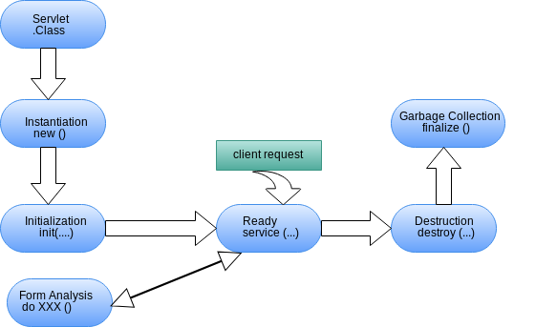

- Servlet Loading.
Container will load LoginServlet.class file’s bytecode into the memory i.e. perform Servlet loading.

Class c = Class.forName(“LoginServlet.class”)

Before loading the servlet, the container will first check whether this particular servlet is loaded beforehand or not. If the servlet is not loaded, then only the container will perform the loading of the servlet.
- Servlet Instantiation
After LoginServlet class loading, the container will prepare an object of LoginServlet (Servlet Instantiation).

Object obj = c.newInstance()
- Servlet Initialization
After Servlet Instantiation, the web container will perform Servlet Initialization. Here the container will call 2 methods on Servlet and pass ServletConfig object in it.
- init (ServletConfig servletConfig)
- init(): init with no parameter.
Server Initiatlization: init(ServletConfig s), init()

These 2 methods belong to GenericServlet class.
- The servlet container calls the init method exactly once after instantiating the servlet.
- The init method must complete successfully before the servlet can receive any requests.
- The servlet container cannot place the servlet into service () if the init method
  - Throws a ServletException
  - Does not return within a time period defined by the Web server

Thread Creation and Data Processing
service(ServletRequest, ServlestResponse) in GenericServlet class
service(HttpServletRequest, HttpServletResponse) in HttpServlet class
doXXX(HttpServletRequest, HttpServletResponse)in LoginServlet class

- As soon as the servlet initialization is complete, the web container will spawn a new thread and call the service () method.
- The service () method checks the HTTP request type (GET, POST, PUT, DELETE, etc.) and calls doGet, doPost, doPut, doDelete, etc. methods as appropriate.
- As the form contains post method, we must implement the doPost() in LoginServlet class.
- The container prepares HttpServletRequest and HttpServletResponse objects.
- The HTTPServletRequest object will contain 3 types of data
  - Request Headers Data: the client browser data
  - Request Parameters Data: the data that we entered in form: u_n, pwd
  - Request Attributes Data: the dynamic data the servlet may include in request attributes
- Response is prepared
- As container executes the doPost(), some data is created in Response object.
- As the response is created and the thread reaches the end point, it service() and doPost() ends
- As the thread is near destroy, the servlet sends the response object to the main server.
- Main server will format the response and give it to protocol and this protocol prepares the header and body part of response.
  - Header will contain type of response, length of response etc.
  - The body will contain dynamic data.
- Response is sent back
- The protocol will carry this data to client machine.
- Browser will get response from body part and parse and display the result.
- As the information is displayed, the protocol will destroy the connection.
- As soon as the connection is destroyed the server will destroy the request and response objects.
- The container will again come in waiting state.

Brief Life cycle
- init() is called when the request is made for the 1st time
- service() is called on every request
- destroy() is called, when the server stops which in turn destroys all servlets

